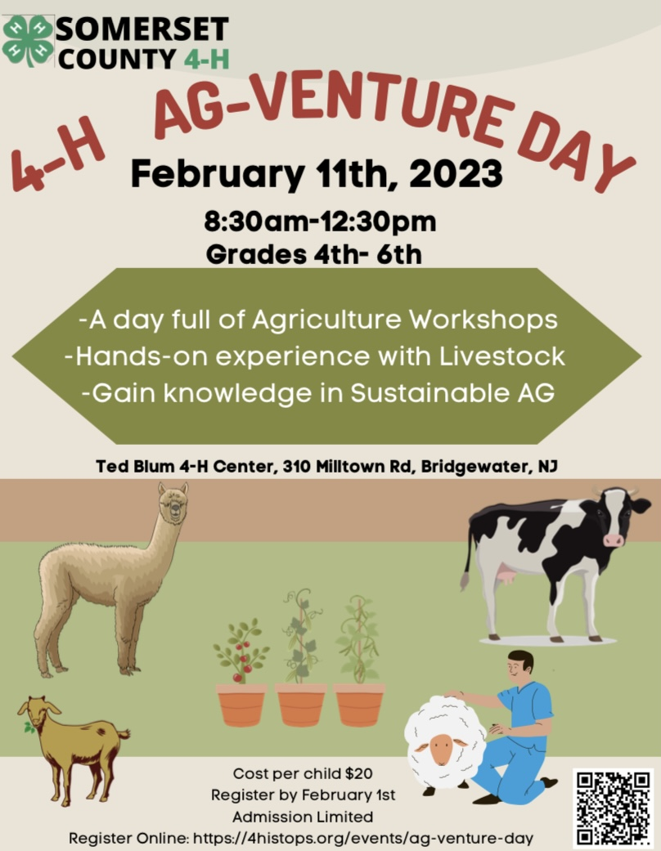
Cooperating Agencies: Rutgers, The State University of New Jersey, U.S. Department of Agriculture, and Boards of County Commissioners. Rutgers Cooperative Extension, a unit of the Rutgers New Jersey Agricultural Experiment Station, is an equal opportunity program provider & employer.

What is 4-H Ag-Venture Day?

4-H AG-Venture Day is a fun day of hands on animal science in agriculture learning for youth participants in grades 4th-6th presented by the Somerset County 4-H Youth Development Program. Youth will participate in hands-on workshops that allow them to learn about a variety of animal science topics in order to further their knowledge in agriculture sustainability.
- The program will be held on Sat., February 11th, 2023 at the Ted Blum 4-H Center, 310 Milltown Rd., Bridgewater, NJ.
- Cost per child is $20. Additional siblings are $15 each.
- Check-in starts at 8:30 AM (no need to come early).
- Event is over by 12:30pm Please arrive on time to pick up your child.
- Participants will stay in their same group all day. As per Rutgers University, mask policy will be determined at that time.
- A parent/legal guardian MUST sign the child in and out of the program. If someone other than the parent/legal guardian is to take the child home, a note from the parent must accompany the child at check-in.
- Children may not leave the program early unless a parent/legal guardian signs them out.

Mail or hand deliver registration forms, and payment to the 4-H Center- at 310 Milltown Road Bridgewater NJ. Cost per child is $20. Additional siblings are $15 each.

Checks should be made payable to: Somerset County 4-H.

Please note: Pictures are taken throughout the day to be used for display and promotional materials. By allowing your child to attend this program, you acknowledge permission to use photos for display and promotional purposes.
What is 4-H?
4-H is a youth development program across America. In New Jersey, the 4-H program is open to youth in grades K-13 (one year out of high school). In Somerset County, youth may be involved in more than 65 different 4-H clubs, after school activities, school enrichment and camping programs. Each summer, the Somerset County 4-H Association holds the Somerset County 4-H Fair at North Branch Park in Bridgewater, NJ. This Fair is an opportunity for youth to display the projects they have been working on throughout the year, take on leadership roles, and have fun. 4-H is part of Rutgers, The State University, New Jersey Agriculture Experiment Station. 4-H offers educational programs to all youth in grades K-13, on an age-appropriate basis, without regard to race, religion, color, national origin, ancestry, sex, sexual orientation, gender identity and expression, disability, atypical hereditary cellular or blood trait, marital status, domestic partnership status, military service, veteran status, and any other category protected by law.

Come and take on the Adventure!
Come and take on an adventure with the Somerset County 4-H Animal Science clubs! Youth in grades 4th-6th will have the opportunity to have a hands-on experience with livestock in order to learn about the agriculture industry, animal science, and the importance of sustaining agriculture. All workshops are taught by 4-H volunteers with a passion for sharing their love of agriculture with youth just like you! The event will be over by 12:30. As per Rutgers University, mask policies will be determined at that time.
Schedule
8:00 – 8:55 am Check In and Welcome
9:00 – 9:45 am Workshop 1
9:50 - 10:35 am Workshop 2
10:40 – 11:25 am Workshop 3
11:30 - 12:15 pm Workshop 4
12:15 pm 12:30pm Evaluations and Goodbye
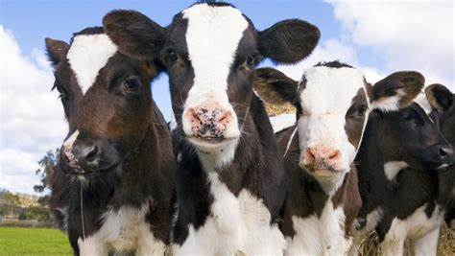
CowaBunga!
Milk, it sure does the body good! Come and learn how milk ventures from the farm to the fridge each and every day. Students will learn about how dairy farms process milk, as well as popular tools and equipment that farmers use each day. A real live calf will be present in order to demonstrate proper procedures on newborn calf care. CowaBunga will be taught by two local dairy farmers and the New Jersey State Dairy Princess.
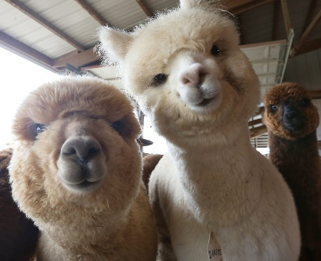
Alpacas in Agriculture
This is your opportunity to meet and greet the Alpacas from the 4-H Alpaca Club. The Alpacas are looking forward to teaching you all about their fiber! You will meet a real live Alpaca to understand how their fiber makes specific clothing we see on the shelves at popular clothing stores. This workshop will be taught by industry professionals who will share their knowledge about Alpaca history, discuss and demonstrate fiber preparation, shearing of the Alpaca, skirting, washing, carding, and spinning the fiber. We welcome you to co me and join the adventure!
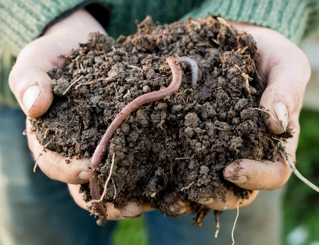
The Worm Workshop
The Rutgers Master Gardeners of Somerset County will present a workshop on Vermicomposting. What is vermicomposting? It is composting BUT with worms! Students will learn how worms help our soil. Master Gardeners will share information on different kinds of worms, what they eat, how they move, and how they stay alive. Everyone will be able to handle and examine worms close up to locate and identify body parts. You'll hear about the science of vermicomposting and the basics you need to establish a worm bin at home.
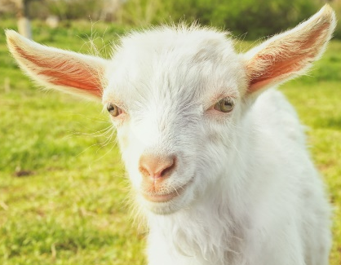
You’ve Goat to Be Kidding Me
A workshop full of goat anatomy mixed with veterinarian small ruminant science. Learn about different tools veterinarians use in order to maintain animal health. This is your opportunity to meet and greet the goats from the Just Kidding 4-H Club. The “kids” from 4-H are looking forward to teaching you about their “kids”! You will greet a real live goat in order to understand how their body works and how it’s different from people! We welcome you to come and join the fun for whatever floats your goat.
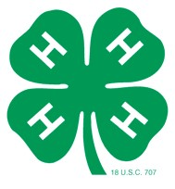
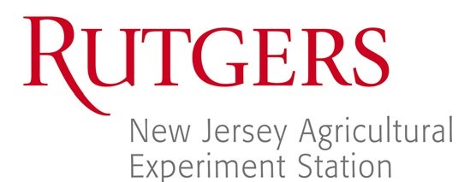
New Jersey 4-H Event
Registration & Permission Form for Youth

Both sides of this form must be completed by all youth participating in overnight activities, field trips, events requiring group transportation, and any other events sponsored through the 4-H Youth Development Program where it is deemed necessary by the event coordinator(s) (paid 4-H staff and/or registered 4-H volunteer) responsible for the youth participants. The form should be submitted prior to the event. The form has five parts: (1) information about the participant and activity, (2) parental permission and liability release, (3) medical emergency authorization and health information, and (4) code of conduct and (5) media policy. Be sure to complete all five parts and sign where requested!

Information about the Youth Participant and Activity

Name of Youth participant: ____________________________________________________________________________Grade: ___________
Preferred Pronouns _________________________________________________ Birthdate: ___________________________
Address: _______________________________________________ City:______________________________ State:_______ Zip:__________
Telephone number: _____________________________________ Email Address: ___________________________________
Are you a 4-H member: ___yes ___no If yes, what in what 4-H county do you belong? _________________________________

Name of activity/event: __Somerset County 4-H Ag-Venture Day

Name of 4-H group sponsoring or participating in this event: Somerset County 4-H

Location of event: _Ted Blum 4-H Center 310 Milltown Rd, Bridgewater, NJ 08807

Date and time of participation of individual named above: February 11th, 2023__8:30 am to 12:30pm

Parent Permission and Release of Liability
I hereby give my son/daughter named above permission to participate in the event listed. Although Rutgers Cooperative Extension and its event coordinator(s) will use the utmost precaution in guarding the health of the above participant and preventing accidents, I release them and their Cooperating Agencies: Rutgers, The State University of New Jersey, U.S. Department of Agriculture, and Boards of County Commissioners, from any liability in case of illness or injury as a result of this activity. Furthermore, I release the owner and driver of the car transporting my child to and from the event, from any liability in case of illness or injury.
Signature of parent or guardian:
_________________________________________________________________
Sign Here

Medical Emergency Authorization and Health Information
I authorize the event coordinator(s) to dispense the prescription drugs and/or over the counter medications listed below in accordance with the instructions provided on the label (prescription drugs) or below (over-the-counter medications). In case of sudden illness or an accident to the above-named participant requiring immediate treatment or surgery while he/she is a participant in this activity, I
authorize the 4-H chaperone(s) to take such action as seems appropriate to protect the health and physical well-being of the above participant. This authority extends to any physician(s) and/or surgeon(s) selected by the event coordinator(s) to perform medical and/or surgical procedures including examinations and tests necessary to preserve the health and physical well-being of the above-named participant. All efforts will be made to contact the parent(s) or guardian(s) in case of emergency.

____________________________ ____________________ __________________________________ __________________
Name of parent/guardian Phone number Name of additional emergency contact Phone number
The following information is provided as an aid to the event coordinator(s) in dealing with the well-being of the participant. The participant has the following health conditions: (include allergies, handicaps, diabetes, pregnancy, asthma, medications needed, etc.).
Health conditions: ___________________________________________________________________________________________
Medications/Instructions: _____________________________________________________________________________________
Health Insurance: Company Group# ___________________________________ ID# _____________________________________
Signature of parent or guardian ________________________________________________________________
Sign Here

New Jersey 4-H Code of Conduct
The primary purpose of the New Jersey 4-H Code of Conduct is to ensure the safety and well-being of all participants at 4-H sponsored events and activities. It applies to all participants, with participants defined as 4-H members, their parents, and volunteers.
As a participant in the 4-H program, I will:
- Conduct myself in a courteous manner and treat members, parents, 4-H volunteers, Extension staff, judges and others with respect. Appropriate language and behavior are expected at all times.
- Respect and adhere to the rules and guidelines of the 4-H program including all those specific to a 4-H event or activity.
- Uphold an individual’s right to dignity by supporting an environment of inclusion which welcomes involvement of participants from all backgrounds.
- Accept supervision and support from county and state 4-H staff while participating in the 4-H program. This includes acceptance of supervision and support from appointed 4-H volunteers coordinating 4-H events and activities.
- Obey local, state and federal laws.
Participants who fail to adhere to the New Jersey 4-H Code of Conduct are subject to a range of disciplinary actions. Such actions will be taken in compliance with the New Jersey 4-H Discipline Policy and Procedure. When appropriate, immediate corrective action will be taken at the 4-H event to ensure the safety and welfare of all participants.
I understand if I fail to adhere to the above Code of Conduct, I will be subject to disciplinary action and potentially prohibited from attending and participating in the New Jersey 4-H Youth Development program.

_______________________________________________________
____________________________________

Signature of participant in event

Date
_______________________________________________________
____________________________________

Signature of parent or guardian

Date
Sign Here
Sign
Here

New Jersey 4-H Media Policy and Release
The 4-H program routinely promotes activities through various media. This includes, but is not limited to newsletters, newspapers, brochures, and displays. In doing so, the names and photos of members may be included to help tell the 4-H story. However, New Jersey 4-H policy is that on web sites, youth in photos will not be identified by name(s).
❑ No, do not use my individual picture for any purpose. I will make an effort to avoid opportunities to be in group photos.
❑ No, do not use my name for any purpose.

Revised: January 2013, December 2019, 2021

