4-H Food ‘N Fun

What is Food ‘N Fun?
Food ‘N Fun is a friendly, food-themed event open to ALL Somerset County 4-H Clubs. Participants share their creativity by selecting a theme and planning a menu and table setting around that theme. Themes do not have to be club related. Past themes have included Disney, Movie Night, Sports, Harry Potter and Big Foot - the possibilities are endless!

Participating club members will each contribute a food or drink (prepared at home), along with the recipe if possible. Clubs will also include an attractive menu and a poster that shows how their menu selections fit into the MyPlate guidelines.

Registration deadline is Friday, March 1, 2024. Email Jennifer Korneski, Healthy Living Program Coordinator at korneski@co.somerset.nj.us to register your club.
Please include the following:
- Club Name
- Theme
- Participating members names

What to Expect
This is a great opportunity for 4-H members to bond together and build skills in teamwork and creativity but also is a valuable learning experience in cooking, table setting and nutrition.

Doors will open at 3:30 pm and clubs will be assigned to a room for final preparations if need, At 4:10, all participants will meet in the large conference room for welcome and instructions. All club members are expected to help set-up and decorate their assigned table in the gym, allowing the judges to observe organization and teamwork.

Once tables are set up, the program will begin with a welcome and pledges. Clubs will enjoy dinner with their members, leaders, and judge. After dinner, each club will present their theme to the whole group and explain how their menu items fit into MyPlate guidelines.

Judging
- One judge will be assigned to eat with and observe a club. Clubs will be judged on how well the chosen theme is displayed. This includes the table setting and display, originality of food choices, teamwork, and including all food groups within MyPlate guidelines.
- Individuals will be judged on the quality of their food, recipes (written or typed neatly), social etiquette (how the member interacts with peers and adults) and knowledge of their dish.
*Members who are absent but who have sent a food entry will not be judged.

Awards
Individual participants will receive a ribbon, based on judging. Prep members will receive a critique and participation award. All clubs will receive a rosette to be exhibited at the Somerset County 4-H Fair.

Parents & Leaders
Remember, this is a learning experience for your 4-H members. Parents traditionally do not attend this event. Leaders, please keep assistance with set up to a minimum. See the Leader packet for all the information needed to prepare your club.

For more information, email Jennifer Korneski, Healthy Living Program Coordinator, at korneski@co.somerset.nj.us

REFERENCES
- www.myplate.gov

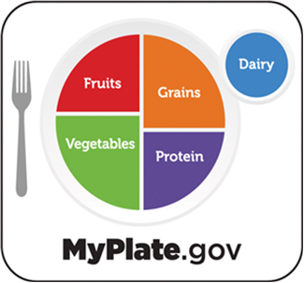

Revised 2024JK

